Product Configurator - Prototype

Product Configurator Design 2

Home Page 2

Report and Activities 3

Menu 3

Product Launch 4

Product Detail 5

Product Maker/Checker Details 6

Product Detail Filter by Status 6

Inquiry 7

Inquiry Details 8

Filter – Business Unit 8

# Product Configurator Design

This document contains UX and UI prototypes for bank product configurator. I have used Flat UI model for dashboard and widgets to ensure better user experience.

# Home Page

It has the following components

1. Menu (My Products -> Product Launch, Product Maintenance and Inquiry)
2. User Details
3. Counts (Pending Approvals and Rejected)
4. Analytics - Product launch report (Day/Week/Month view)
5. User Recent Activities

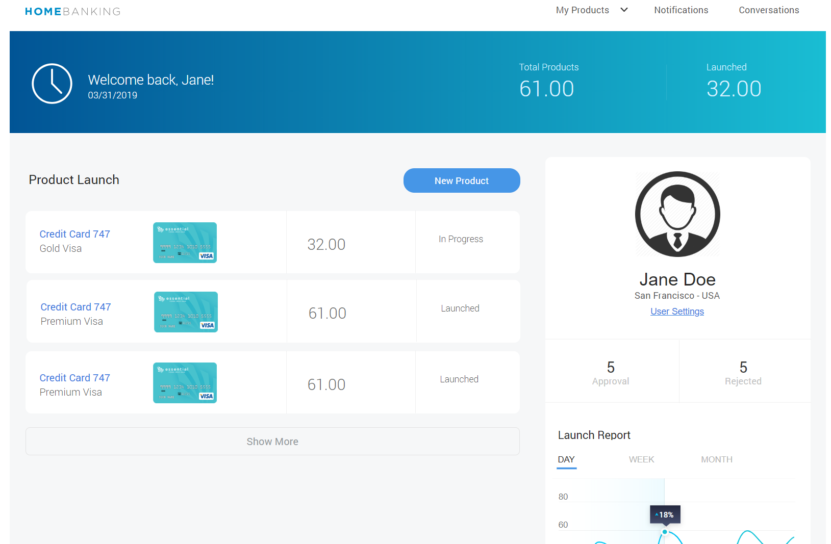

## Report and Activities

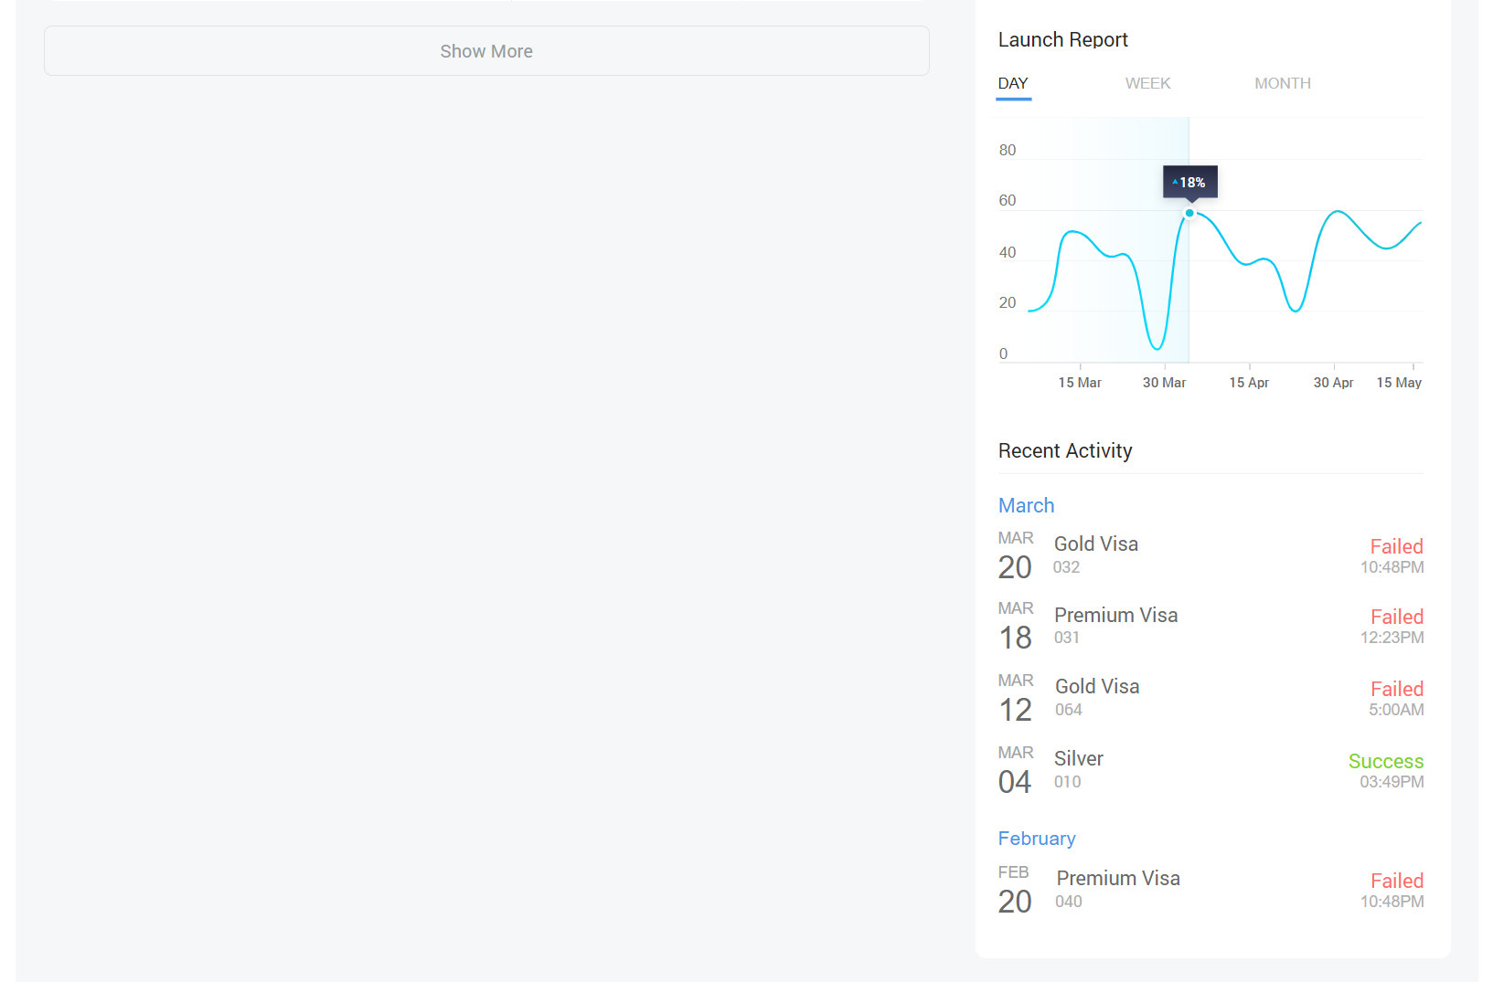

## Menu

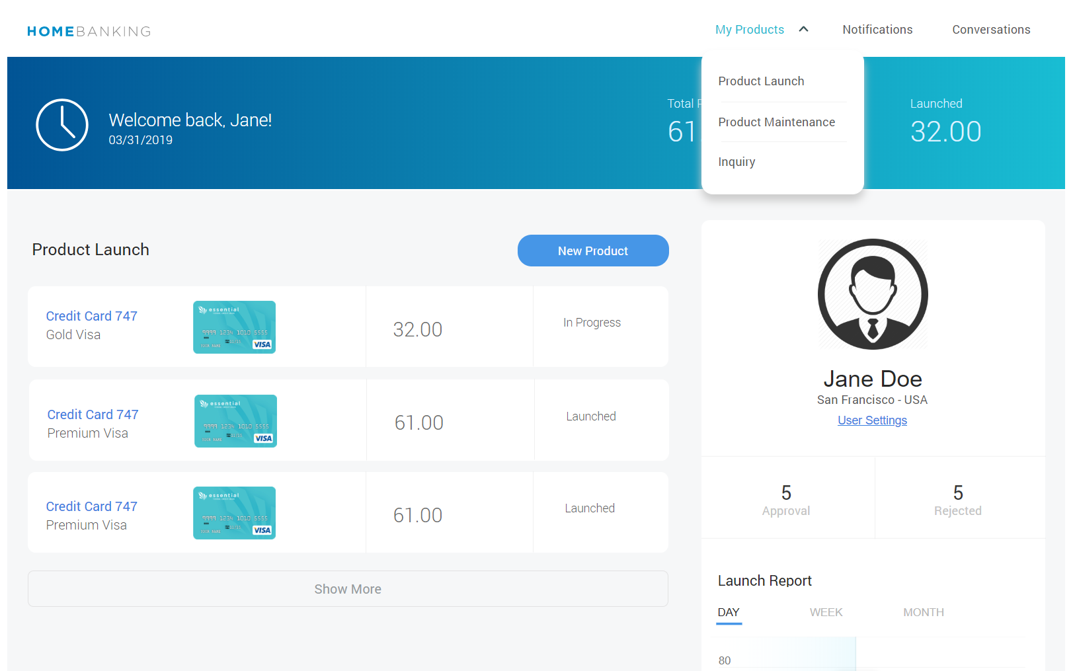

# Product Launch

This is a widget component and currently I have included in the home page. We can also access this from Menu -> Product Launch

It contains the following fields

1. Product Type - ORG
2. Product Description
3. LOGO
4. Status

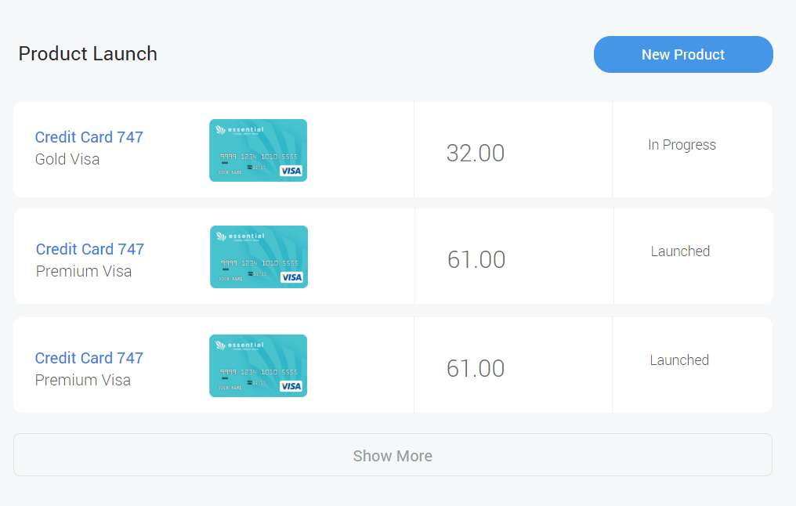

## Product Detail

Click on the product to view the product details.

1. It contains all records related to a selected product
2. We can also filter the records by status
3. Click on product launch button to go back

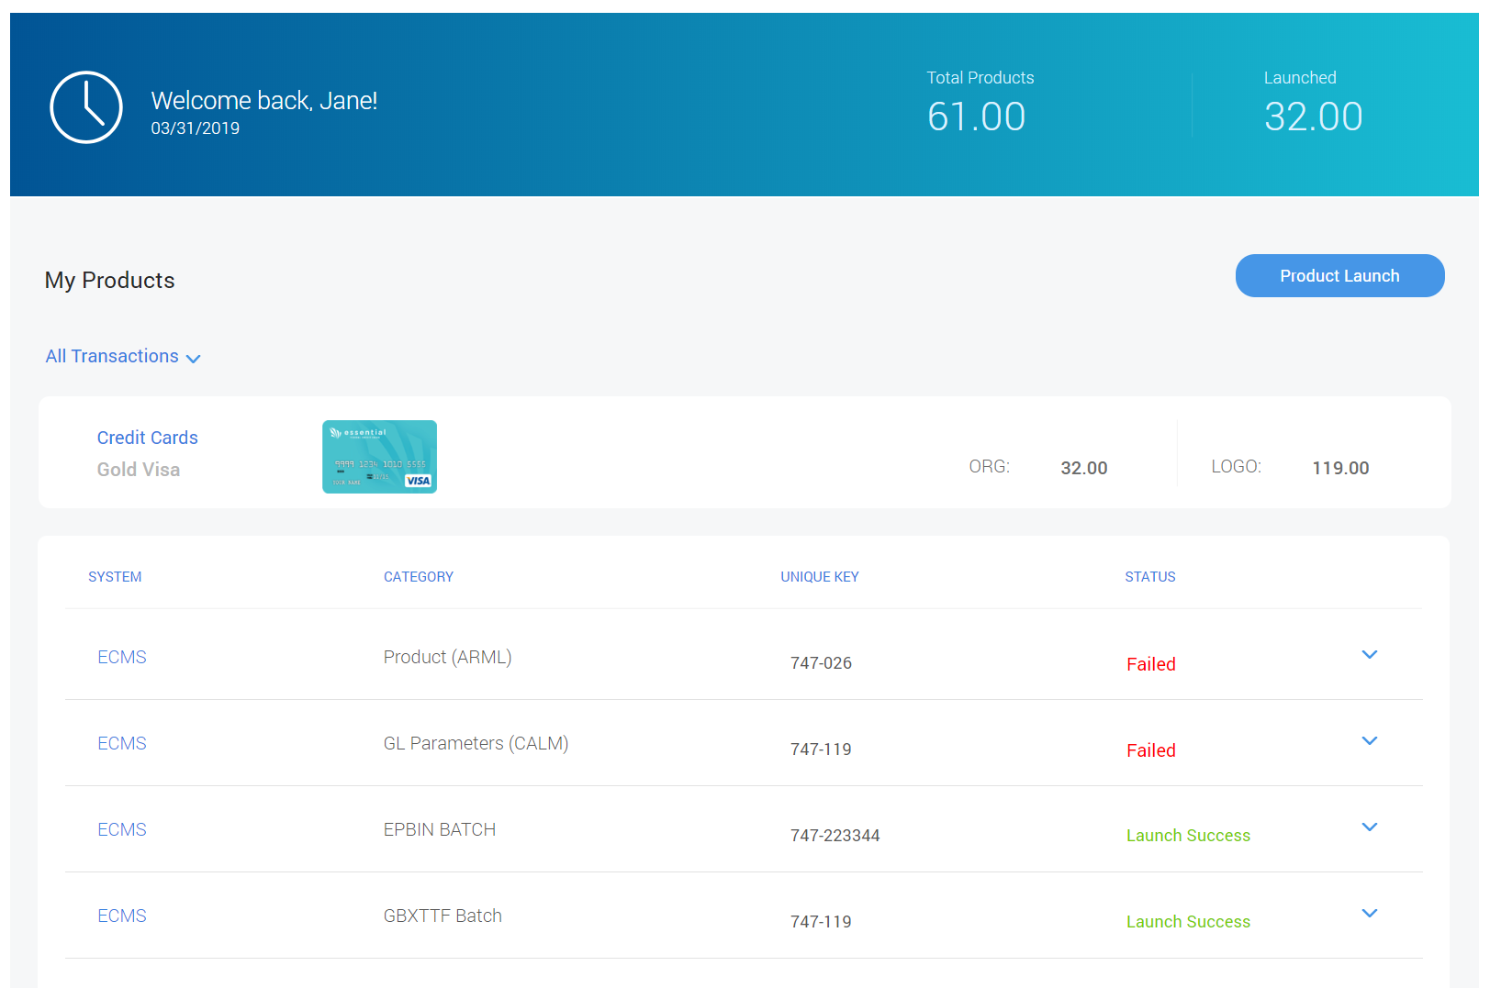

## Product Maker/Checker Details

Click on the arrow to view more details like created by, created date, authorized by and authorized on. Only for Super user Delete button will be available.

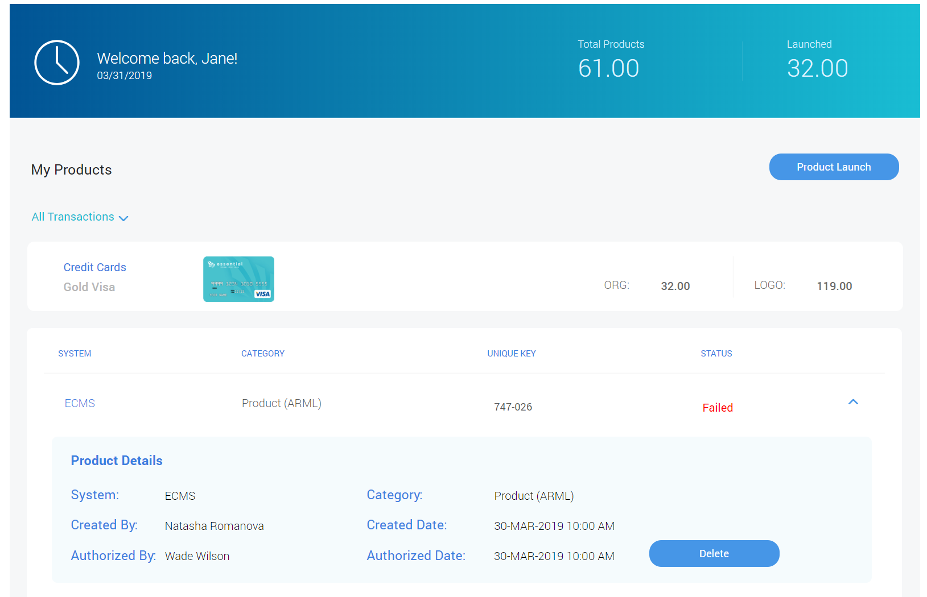

## Product Detail Filter by Status

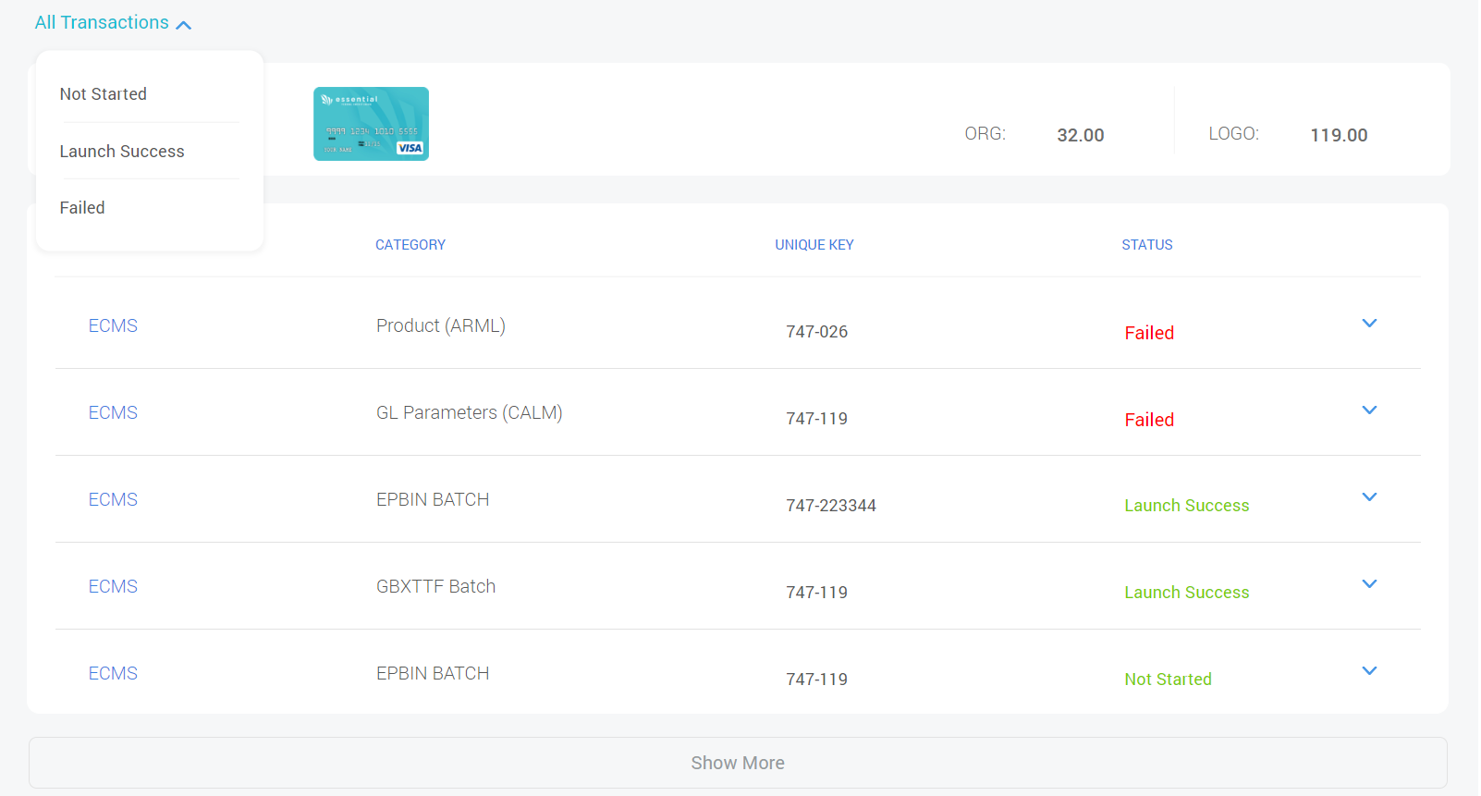

# Inquiry

Click on My Products -> Inquiry

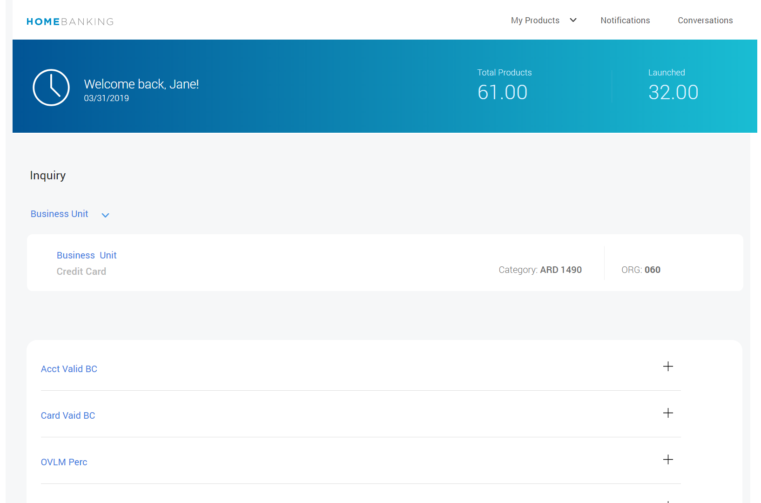

## Inquiry Details

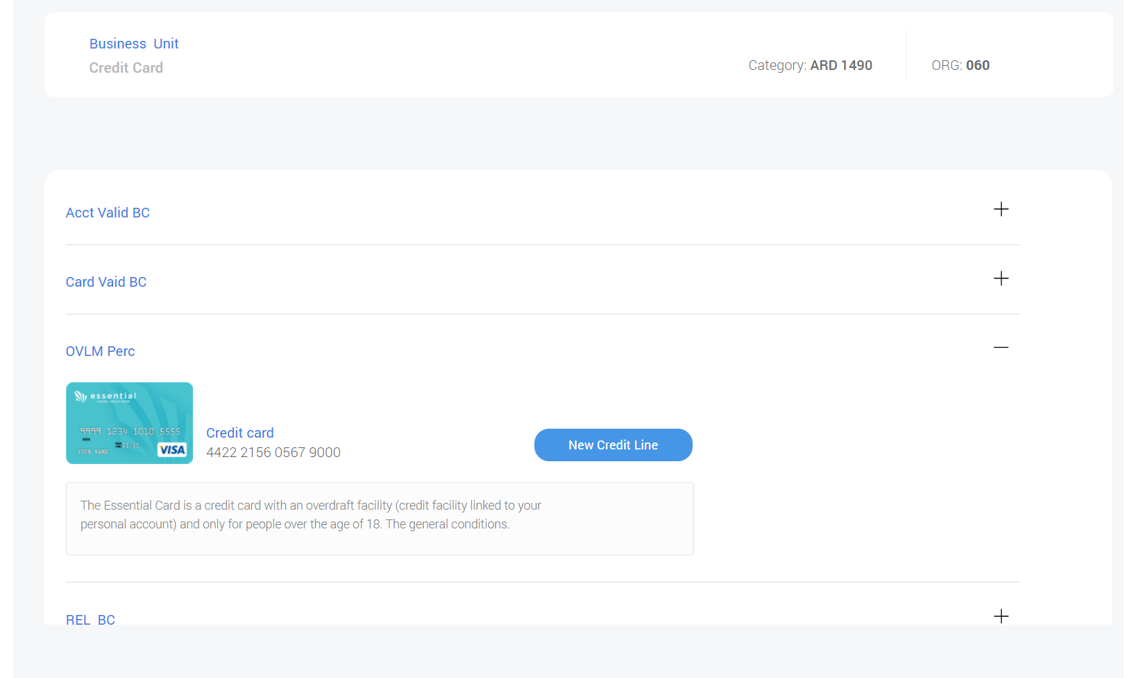

## Filter – Business Unit

